Ideation Phase
Empathize & Discover

Date | 17 February 2026
Team ID | LTVIP2026TMIDS78778
Project Name | Gemini Historical Artifact Description
Maximum Marks | 4 Marks
Empathy Map Canvas
The Empathy Map helps the team understand the users of the Gemini Historical Artifact Description application by analyzing their thoughts, needs, frustrations, and goals. This ensures the solution is user-centered and aligned with real challenges faced by historians, students, museum curators, and content creators.
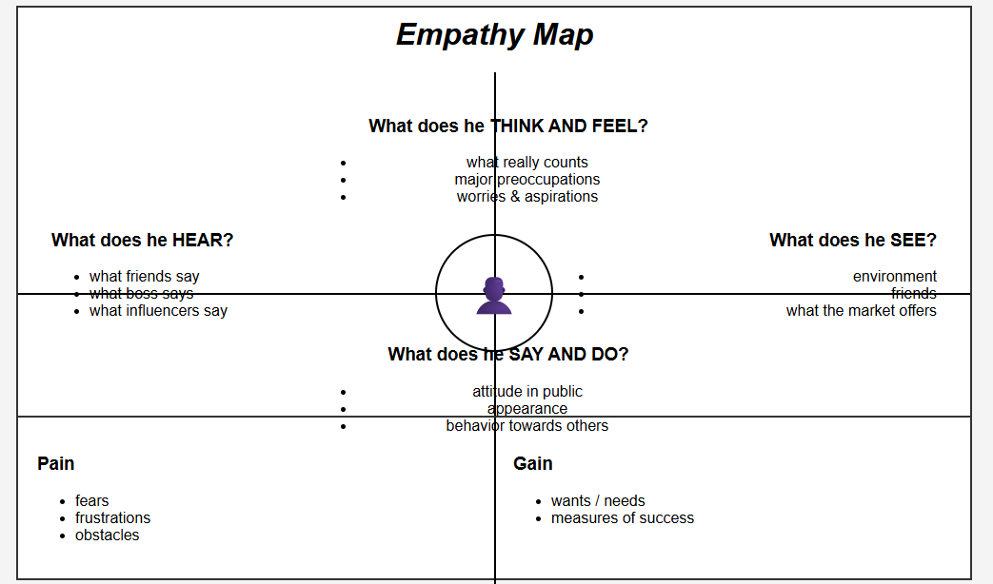

Target User Group
Historians, museum curators, history students, bloggers, and researchers who need accurate and structured historical artifact descriptions.

Empathy Map – Gemini Historical Artifact Description
- Says
- “I need accurate historical information for my research.”
- “I want well-structured descriptions for exhibitions or blogs.”
- “It takes too much time to gather reliable historical facts.”
- “I am not sure if my interpretation of this artifact is correct.”
- Thinks
- “Is this information historically accurate?”
- “How can I make this content more engaging and informative?”
- “There must be a faster way to generate detailed descriptions.”
- “Understanding this artifact’s context requires deep expertise.”
- Does
- Searches multiple websites and research papers
- Refers to books and academic sources
- Spends hours compiling and structuring information
- Uploads artifact images to identify context
- Edits and rewrites content multiple times
- Feels
- Overwhelmed by scattered information
- Frustrated due to time constraints
- Confused when interpreting artifact images
- Concerned about accuracy and authenticity
- Relieved when reliable structured content is generated
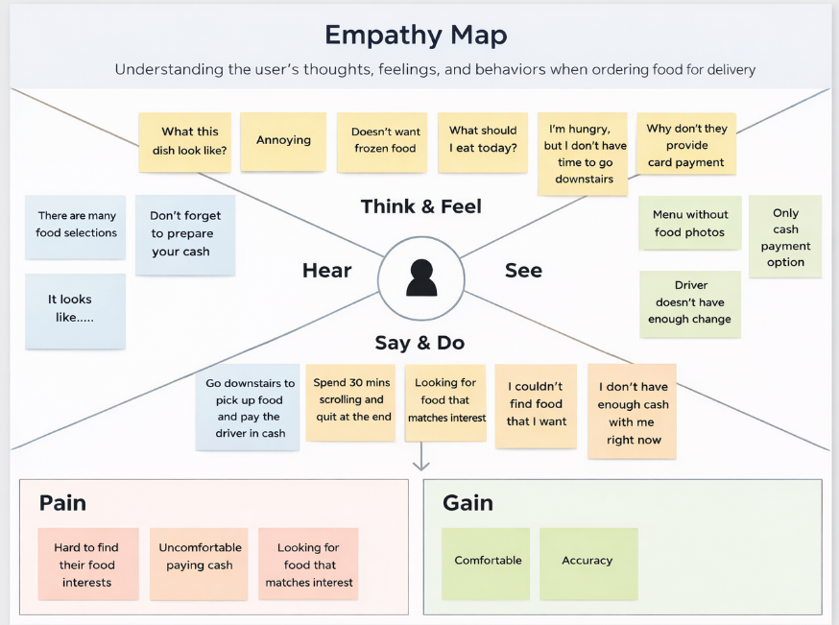
User Goals
- Generate accurate and detailed artifact descriptions
- Save time in research and content creation
- Receive structured and well-formatted outputs
- Understand artifact history from both text and images

User Pain Points
- Time-consuming research process
- Lack of centralized historical information
- Difficulty interpreting visual artifacts
- Fear of including incorrect historical details

Conclusion
By understanding the user’s thoughts, actions, and emotions, the team identified the need for an AI-powered solution that generates reliable, structured, and engaging historical artifact descriptions using both text and image inputs through Gemini 1.5 Flash integrated with Streamlit.

